SOURCE BOOKLET – Year 10 Geography

**DO NOT WRITE ON THE SOURCE BOOKLET**

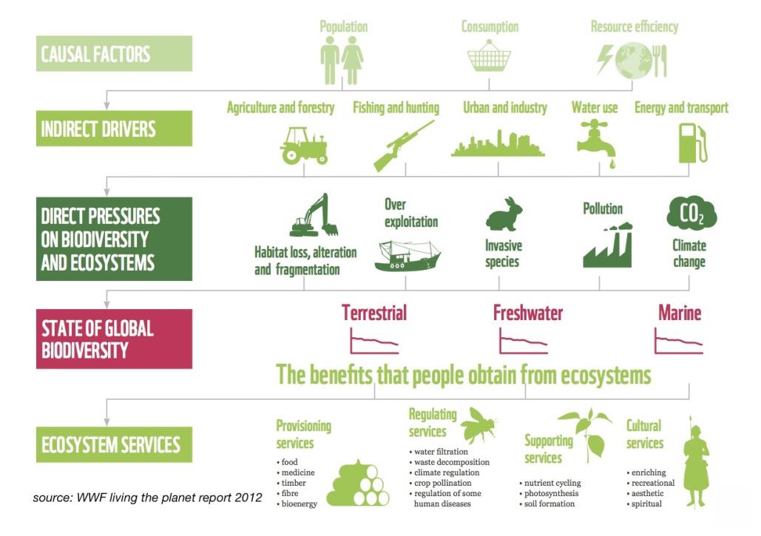

**Source 1**

SOURCE: <https://cr2014studyabroad.wordpress.com/daily-topic-updates/ecosystem-services/> (Date accessed: 5/3/2018)

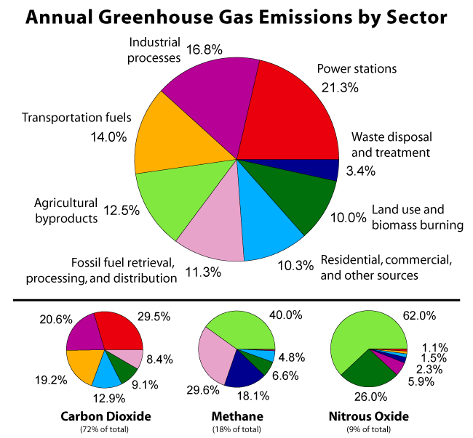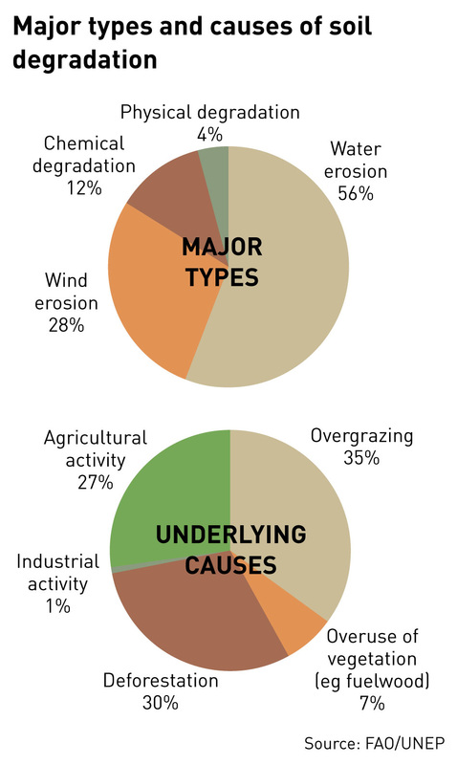

**Source 3**

**Source 2**

SOURCE: <https://livelongthrive.wordpress.com/2014/02/06/resolving-nutritional-deficiency-naturally-part-5/> (Date accessed: 5/3/2018)

SOURCE: <http://globalwarming-facts.info/causes-global-warming-human/> (Date accessed: 5/3/2018)

**DO NOT WRITE ON THE SOURCE BOOKLET**

**Source 4**

**DO NOT WRITE ON THE SOURCE BOOKLET**

Harris.G et al (2007). Humanities Alive Geography 10 Second Edition, John Wiley & Sons Australia, Milton

**Source 5**

**DO NOT WRITE ON THE SOURCE BOOKLET**

Kleeman.G et al (2008). Australian Explorations Stage 5 Geography, Heinemann Harcourt Education, Port Melbourne